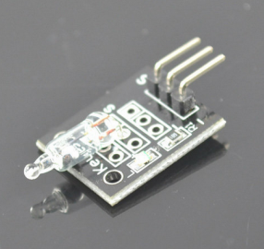
This project will use Mercury Tilt Switch module to sense the tilt. When the module tilt angle changes, the LED will be turned on or off.
Step 1: Connect the module as per following circuit graph:
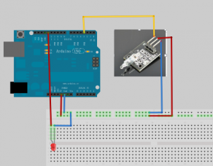
Step 2:Download example code and load it into Arduino.
Step 3: Run the arduino code and you will see result same as following video.

